For using this in Latte, you have to do the following:
1. Copy the mAfeCTestWrapper.py in \Documents\Texas Instruments\Latte\lib\Afe79xxLibraries\AFE79xxLibraryPG1p0\resourceFiles
2. Copy the CTesting.py in \Documents\Texas Instruments\Latte\projects\AFE79xx\bringup.
3. Copy the 3 DLLs in \TI Drive\WI_Apps\AFE79xx_Internal\CLibs\CAFE\CAFEInternal2p0\Afe79xxTI to C:\Program Files\Texas Instruments\Latte\bin
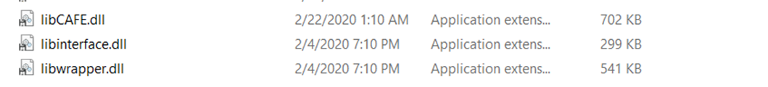
4. Open Latte and run regular Setup and devInit as normal.
5. Run the GPIO commands if needed
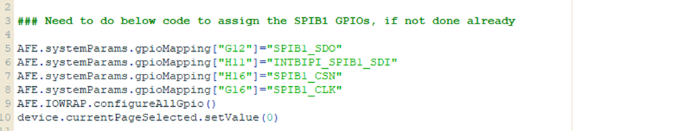
6. Load the Wrapper-DLL
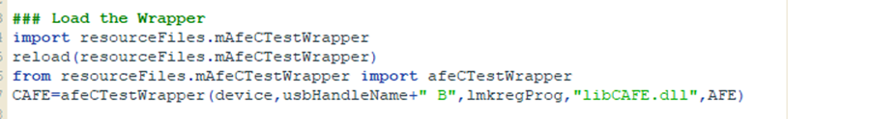
7. Run the functions you want.
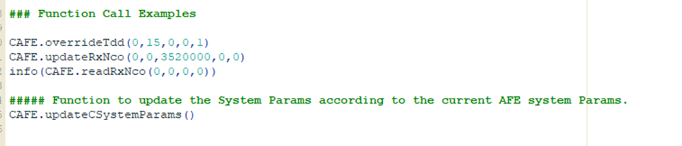
8. The log file will be in C:\Program Files\Texas Instruments\Latte\bin with the set file name. Default is Afe79xx_Clog.txt.

